**PROJECT REPORT**

**IT Training Institute Inquiry Data Analysis**

**Project Name:** IT Training Institute Inquiry Data Analysis  
**Technology Used:** Tableau

* **Introduction:**

This report provides a comprehensive analysis of the student inquiries for various courses offered by an IT training institute. The data consists of inquiries made by prospective students for different technical courses across multiple modes of study, locations, and colleges. The objective of this analysis is to gain insights into the preferences of students based on their course choices, mode of study, location, follow-up status, and course duration. This will help the institute to understand trends and plan marketing and training strategies accordingly.

#### **Most Inquired Courses:**

**Insight:**

* The most in-demand course is **Data Analytics**, with 55 inquiries, reflecting a growing interest in data-related fields.
* **Software Testing** follows closely with 48 inquiries, indicating steady demand for quality assurance skills.
* Other popular courses include **Full Stack Java Developer** (42 inquiries) and **Full Stack Python Developer** (41 inquiries).
* **MEAN Stack Developer** (39 inquiries) and **Data Structures & Algorithms** (33 inquiries) show a good level of interest, suggesting a demand for web development and algorithm skills.
* **Android App Development** and **MEAN Developer** show lower inquiries (30 and 4, respectively), which may indicate a need for increased promotion or curriculum updates in these areas.

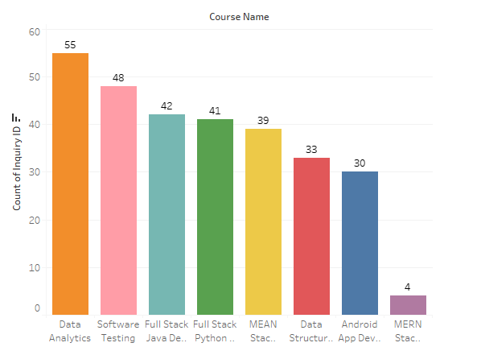

* **Mode of Study:**

**Insight:**

* The **Hybrid** mode of study leads with **112 inquiries**, showing that students are increasingly preferring a mix of online and offline learning.
* **Offline** mode follows with **96 inquiries**, highlighting the importance of in-person learning for many students.
* **Online** mode has **84 inquiries**, reflecting a steady interest in remote learning options.

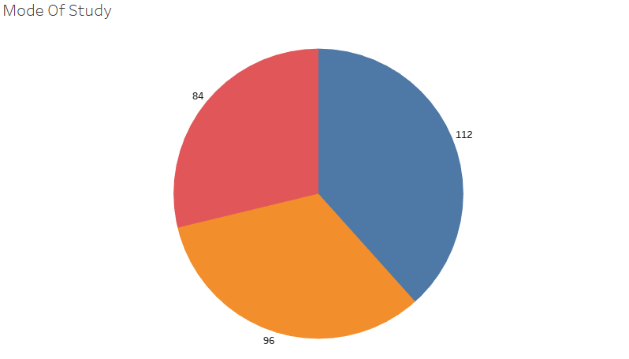 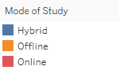

#### **Location of Inquiries:**

**Insight:**

* The **Baner, Pune** location leads with **45 inquiries**, making it the top source of interest for courses.
* Other locations like **Kothrud, Pune** (40 inquiries) and **Hadapsar, Pune** (37 inquiries) also show strong interest.
* Locations such as **Kharadi, Pune** (34 inquiries) and **Yerawada, Pune** (31 inquiries) demonstrate consistent demand, indicating the geographical spread of interest in IT training programs.

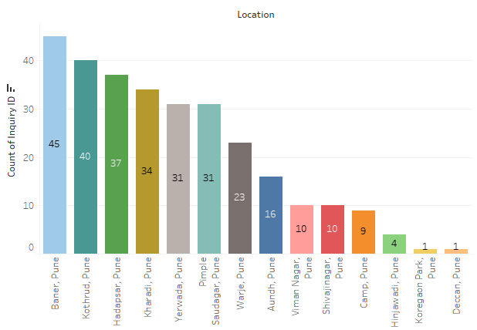

#### **College Name:**

**Insight:**

* **MIT College of Engineering** (66 inquiries) and **COEP (College of Engineering Pune)** (63 inquiries) are the top sources of inquiries, indicating strong academic foundations and interest from these prestigious institutions.
* **Symbiosis Institute of Computer Studies** and **Pune University** both show **62 inquiries**, suggesting that students from these well-known institutes are actively seeking additional training opportunities.
* **Bharati Vidyapeeth University** (17 inquiries) shows fewer inquiries, potentially indicating a need for targeted marketing in this area.

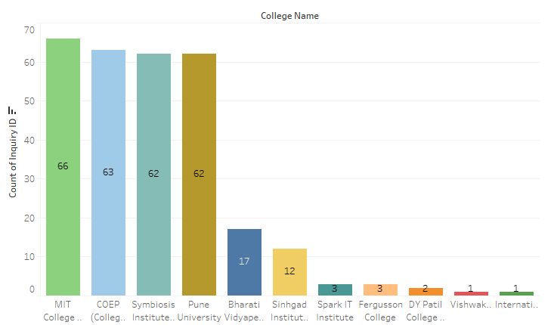

#### **Follow-up Status:**

**Insight:**

* **266 inquiries** have a **positive follow-up status**, indicating that most students are actively engaged and likely to pursue further information about courses.
* Only **26 inquiries** have a **negative follow-up status**, which suggests a small portion of students who may not be interested in pursuing their inquiry further.

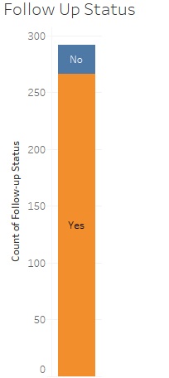

#### **Course Duration Preferences:**

**Insight:**

* The most chosen **course duration** is **3 months** (135 inquiries), which aligns with students' preference for shorter, intensive courses.
* **6 months** duration courses follow closely with **130 inquiries**, showing that students are also interested in more extended learning opportunities.
* A very small number of students (1 inquiry) preferred a **2-month** course, indicating that shorter courses are generally more appealing.

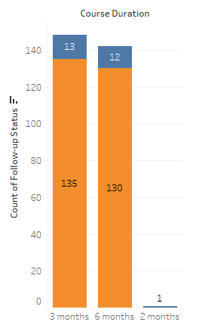

* **Conclusion:**

Based on the analysis of the inquiry data, the IT training institute can derive several key insights:

1. **Data Analytics** is the most in-demand course, and it is recommended to invest more in promoting this course.
2. **Hybrid learning** is the most preferred mode of study, reflecting a balance between flexibility and in-person learning. The institute can consider expanding hybrid options for other courses.
3. The **Baner, Pune** area shows the highest number of inquiries, but other locations like **Kothrud** and **Hadapsar** also demonstrate significant interest.
4. Prestigious colleges like **MIT College of Engineering** and **COEP** are major sources of inquiries, and targeted marketing efforts can be focused on these institutions.
5. Most students prefer a **3-month course**, and the institute may consider offering more short-term, intensive programs to meet this demand.